MANUAL GUIDE ON HOW TO USE THE WEBSITE:

FIRST STEP,

Go to the website and it will appear like this (disclaimer it might be a little different depends on what browser you use). If you want to edit the file directly without have to download it, you just need to click the “Edit File (Excel)”.

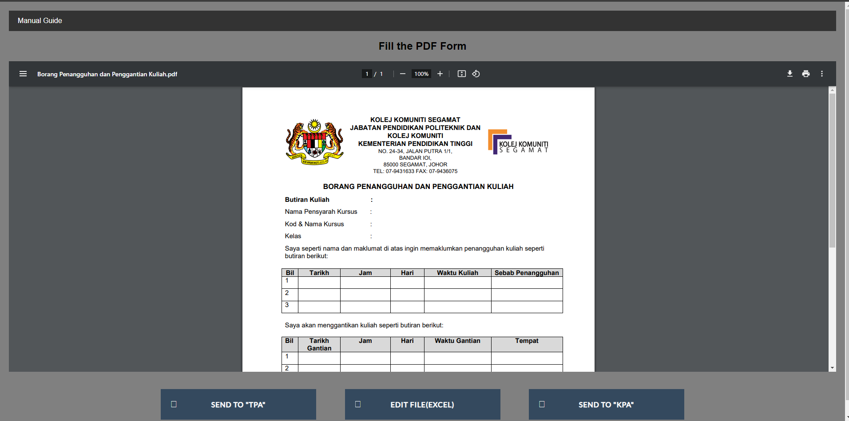

After that you will redirect to a new page that contains the form in spreadsheet to make it easier for you to edit.

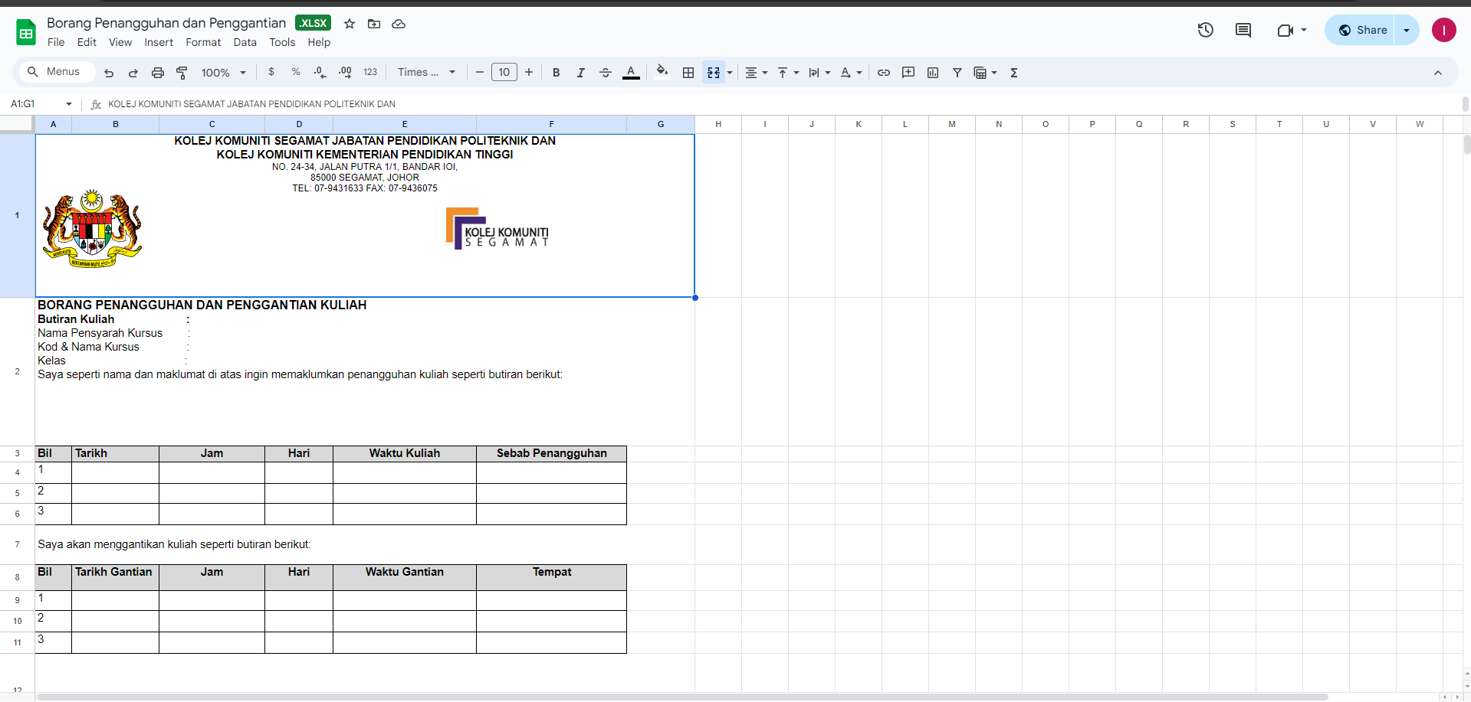

When you already finish with editing you can go and click on file and then download and under download choose as .pdf. And then proceed to download the file.

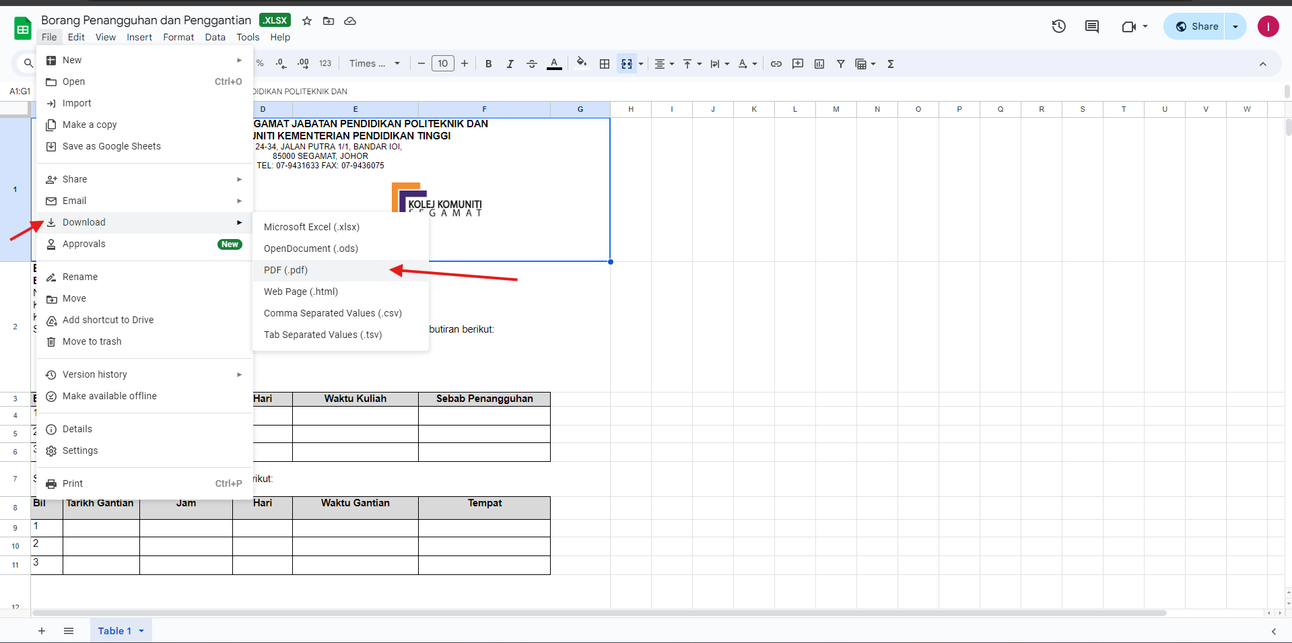

Lastly you can send it to either “TPA” or “KPA”. Just click on which personnel you want to send it to and it will redirect directly to a Gmail. You need to attach the file in the email. That is all for manual guide on how to use this website.